**Event-Finder**

**ScreenShots**

**Project Structure**

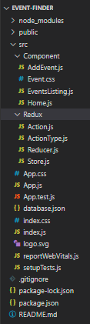

**This is the Home page where all the Events are displayed in a order from the Json server API**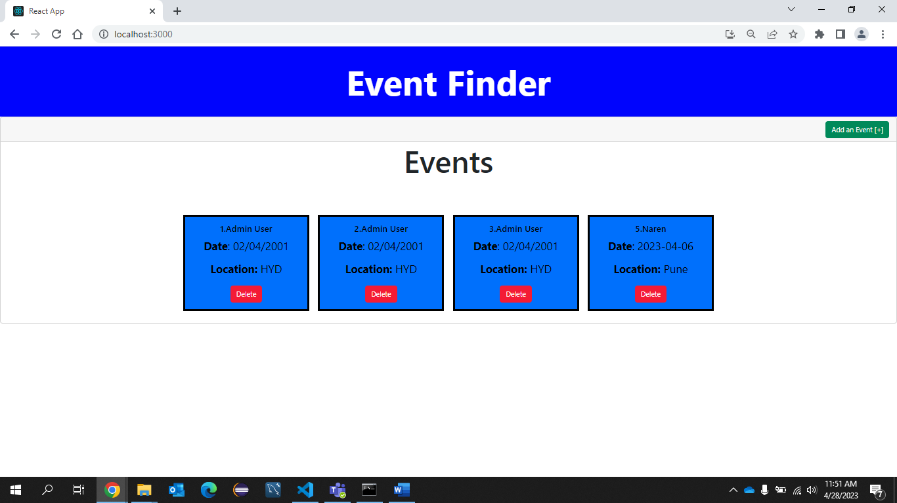

**We can add an event I have added some basic parameters like name of the event data , location**

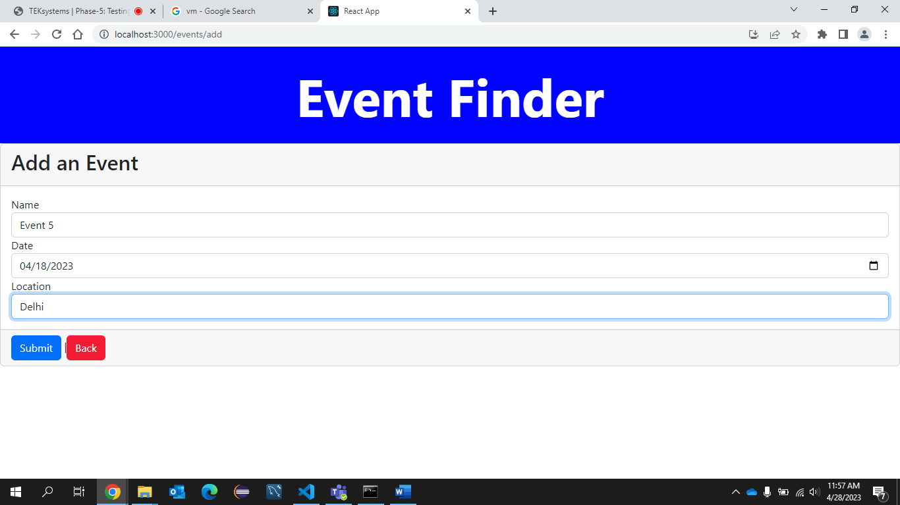

**After adding we will get a pop up message in the right-bottom that the event is added**

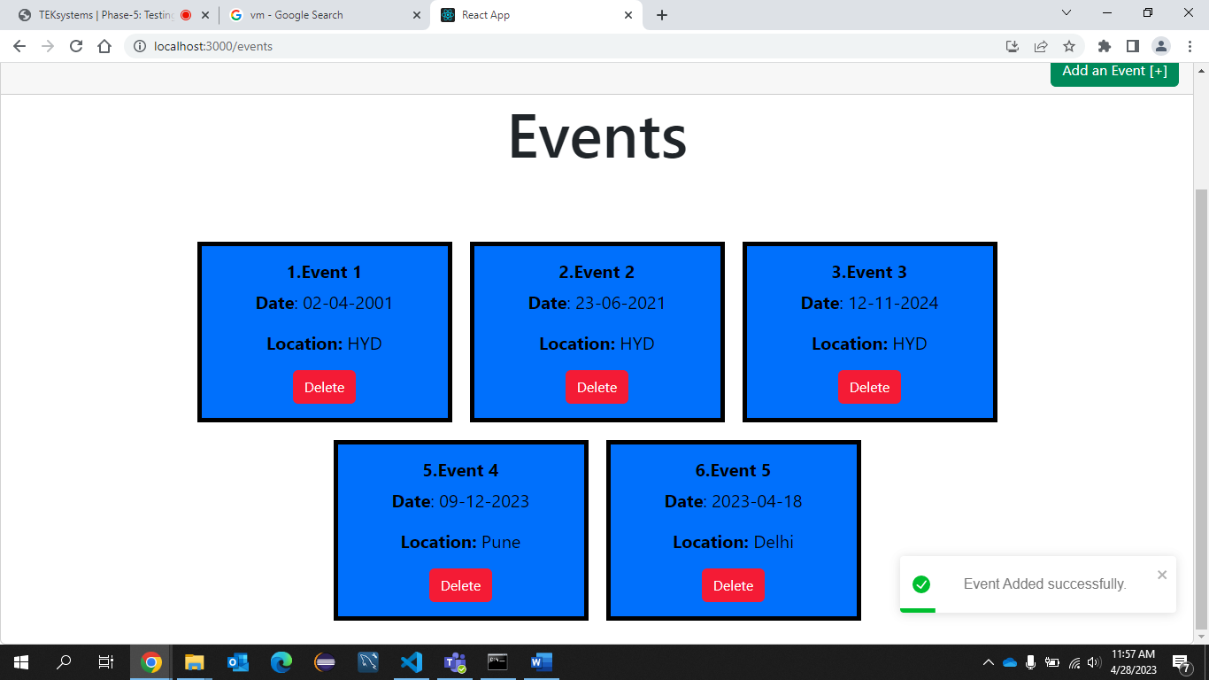

**If we click on delete it will show a prompt for conformation**

**Click on ok**

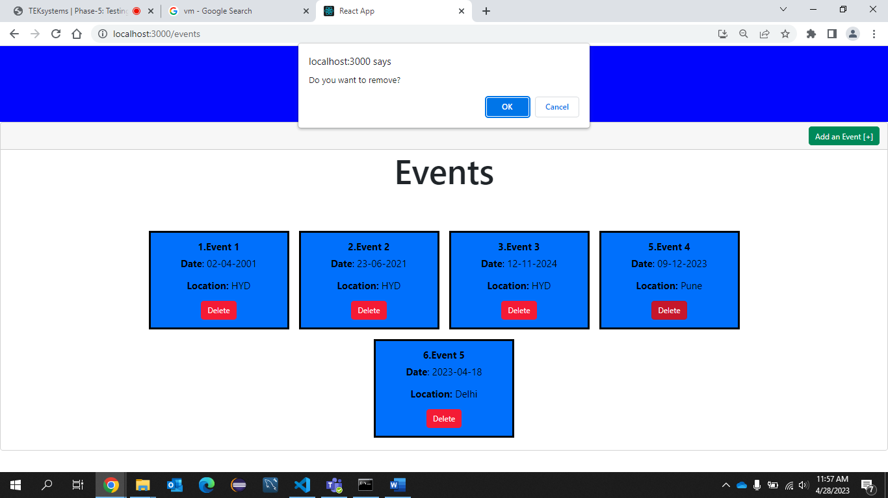

**The event 5 id deleted**

